/\*---------------------------------------------------------------------

Programming Assignment 3 Submission

Queues -- Use a Queue and Stack to test if a string is a Palindrome

Created by Hyo Lee

Student ID: 002292770

01/26/2016

----------------------------------------------------------------------\*/

For this assignment, since we are trying to compare if the characters match in reverse order, I used ‘isalnum’ from the STL to detect only alphabet letters and numbers so that I could ignore punctuation, spaces, and capitalized letters.

Screenshot #1 uses the string in the example provided, and anna is correctly detected as a palindrome.

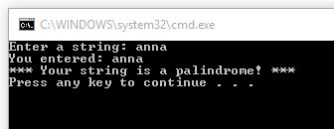

Screenshot #2 uses a mix of spaces, punctuation, numbers, and upper and lowercase letters and still correctly detects the string as a palindrome.

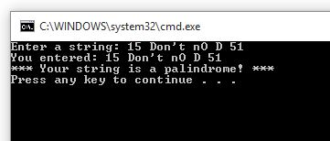

Screenshot #3 correctly detects if no string was entered by the user.

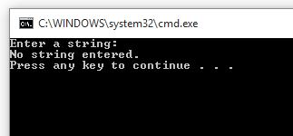

Screenshot #4 correctly detects just numbers that are in palindrome order.

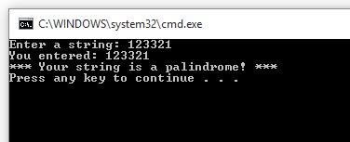

Screenshot #5 correctly detects numbers that is NOT a palindrome.

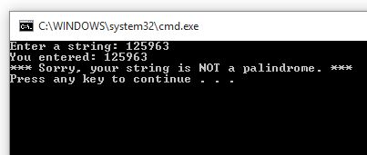

Screenshot #6 correctly detects a string that is NOT a palindrome.

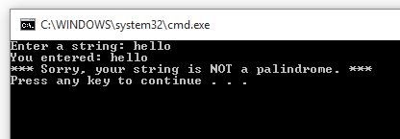

Screenshot #7 correctly detects a string with mixed alpha and nums as NOT a palindrome because the numbers are not in correct reverse order.

